**Department of Computer Science and Engineering**

|  |  |
| --- | --- |
| **Course Code:CSE260** | **Credits: 1.5** |
| **Course Name: Digital Logic Design** | **Semester: Fall’18** |

**Lab 10  
Implementation of Shift Register and Ring Counter**

1. **Topic Overview:**

The students will learn the applications of flip flop.

1. **Lesson Fit:**

The lab requires the knowledge on previous lab and theory knowledge.

1. **Learning Outcome:**

After this lecture, the students will be able to:

* 1. Implement shift register
  2. Implement Ring counter

1. **Anticipated Challenges and Possible Solutions**
   1. **Problem:** Student may not understand how to set up flip flop ICs on bread board.

**Solution:** Demonstrate them the process for an IC

* 1. **Problem:** Student may not understand the mechanism of shift register and counter

**Solution:** Discuss the mapping among the flip flop, the counter and register.

1. **Acceptance and Evaluation**

Students will show their progress as they complete each problem. They will be marked according to their class performance. Their maybe students who might not be able to finish all tasks, they will submit them later and give a viva to get their performance mark.

1. **Activity Detail**
   1. **Hour: 1  
      Discussion:**Explain the flip flop and shift register. **Problem Task:** Set up the shift register
   2. **Hour: 2 & 3**

**Discussion:**

Explain the ring counter

**Problem Task:** Set up the ring counter

**Lab 1 Activity List**

# Experiment # 9

Data Transfer using Shift Register and Implementation Ring Counter.

Register that is capable of shifting data one bit at a time is called a shift register. The logical configuration of a serial shift register consists of a chain of flip-flops connected in cascade, with the output of one flip-flop being connected to the input of its neighbor. The operation of the shift register is synchronous; thus each flip-flop is connected to a common clock. Using D flip-flops forms the simplest type of shift-registers.

You have undoubtedly seen shift registers in action in devices such as an electronic calculator, where the digits shown on the display shift over each time you key in a new digit. This is the same action, taking place in a shift register.

Figure shows the simplest possible shift register.

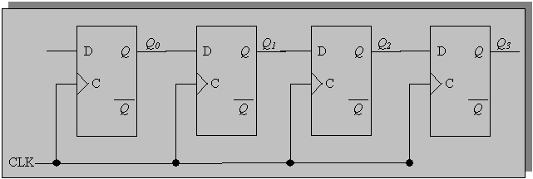

Ring Counter: A ring counter is basically a circulating shift register in which the output of the most significant stage is fed back to the input of the least significant stage.  The following is a ***4-bit ring counter*** constructed from D flip-flops.  The output of each stage is shifted into the next stage on the positive edge of a clock pulse.

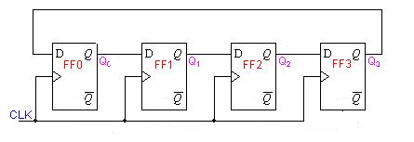

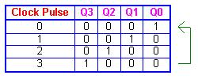

1. **Implement a 4-bit shift register using D- latch.**
2. **Implement a Ring Counter using this 4-bit shift register.**

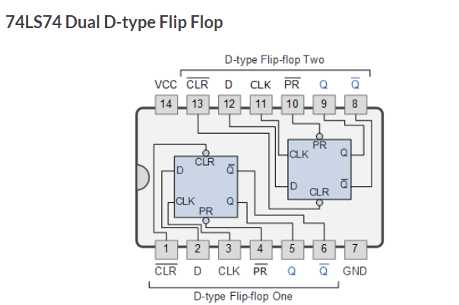

***Report:***

The report should cover the followings

1. Name of the Experiment
2. Objective
3. Required Components and Equipments
4. Experimental Setup (No need to draw the IC configurations)
5. Results and Discussions .The discussions part must include the answers of the following questions:
   1. What is the difference between a register and a latch?
   2. In your design which operation you went for – parallel or serial operation?
   3. What are the advantages of these two operations over one another?